**GLAUCOMA DETECTION ON RETINAL FUNDUS IMAGES USING ADAPTIVE THRESHOLDING AND SUPPORT VECTOR MACHINE**

Name : Ahmad Mustofa

NRP : 5112100100

Department : Informatics, FTIf-ITS

SupervisorI : Prof. Ir. Handayani Tjandrasa,M.Sc.,

Ph.D.

SupervisorII : Bilqis Amaliah, S.Kom., M.Kom.

# *Abstract*

*Glaucoma is the second most common cause of blindness after cataract. Unlike the cataract, blindness caused by glaucoma is permanent. Since glaucoma is caused by great pressure on the eyeball that results in blockage of the blood vessels leading to the nerves of the eye such that the eye nerves do not get enough blood supply and eventually will be damaged. Symptoms of glaucoma that arise usually can not be felt directly. So we need an eye examination to detect glaucoma.*

*In this final project, a software to detect glaucoma on retinal fundus images are built. The first stage in this final project is image preprocessing. Preprocessing stage is divided into optic cuppreprocessing, optic diskpreprocessing, and blood vessels preprocessing. Then optic cup, optic disc and blood vesselssegmentation are performed using adaptive thresholding. After the segmentation process is complete, the Cup to Disk Ratio (CDR), ISNT Neuro Retinal Rim (NRR), and ISNT blood vessels features will be extracted from each image that has been segmented. These three features are then used as inputs in support vector machine classifier using sequential minimal optimization method to search hyperplane and linear kernel function. By using the data drawn from the database RIM-ONE revision 2, the average of system’s accuracy is 80%.*

***Keywords: glaukoma , optic cup, optic disk, segmentation, classification***

## Uji Coba Sistem

Pada bagian ini akan ditampilkan hasil dari masing-masing proses pada sistem pendeteksi penyakit glaukoma dari citra retina mata.

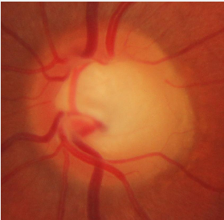

Gambar 5.1 Citra masukan sistem

Tahap pertama yang dilalui citra masukan adalah tahap *preprocessing*.Gambar 5.2, 5.3, dan 5.4 secara berturut turut adalah hasil dari tahap *preprocessing optic disk*, *optic cup*, dan pembuluh darah.



Gambar 5.2Hasil *preprocessingoptic disk*

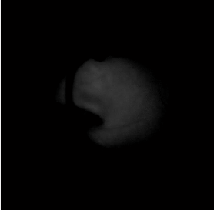

Gambar 5.3Hasil *preprocessingoptic cup*

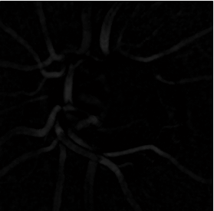

Gambar 5.4Hasil *preprocessing*pembuluh darah

Setelah tahap ini, masing-masing citra keluaran akan masuk pada tahap segmentasi. Gambar 5.5, 5.6 dan 5.7 secara berturut turut adalah hasil dari tahap segmentasi *optic disk*, *optic cup*, dan pembuluh darah.



Gambar 5.5Hasil segmentasi *optic disk*



Gambar 5.6Hasil segmentasi *optic cup*



Gambar 5.7Hasil segmentasi pembuluh darah

Setelah citra berhasil disegmentasi, maka akan dihitung nilai dari masing-masing fitur yang akan dipakai oleh sistem. Berikut ini hasil dari tahap ekstraksi fitur.

* Cup to Disk Ratio = 0.44684
* ISNT Neuro Retinal Rim = 1.0502

ISNT Pembuluh Darah = 0.80558